1. Create a new GitHub repository.

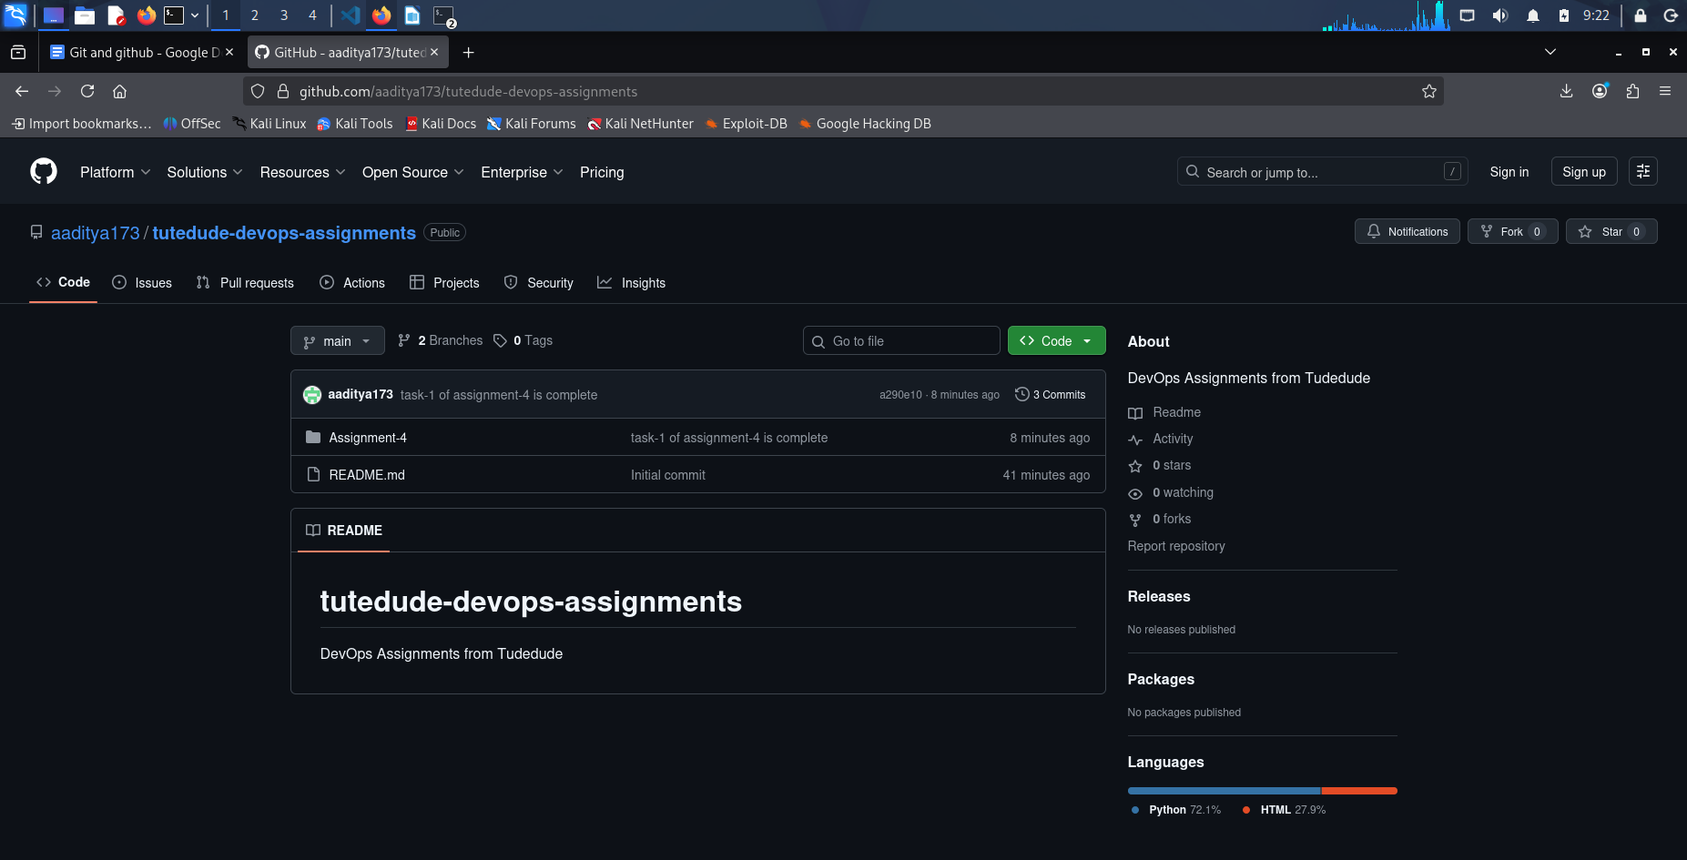
- Clone the repository to your local machine using SSH (generate an SSH key if needed, add the public key to your GitHub account).

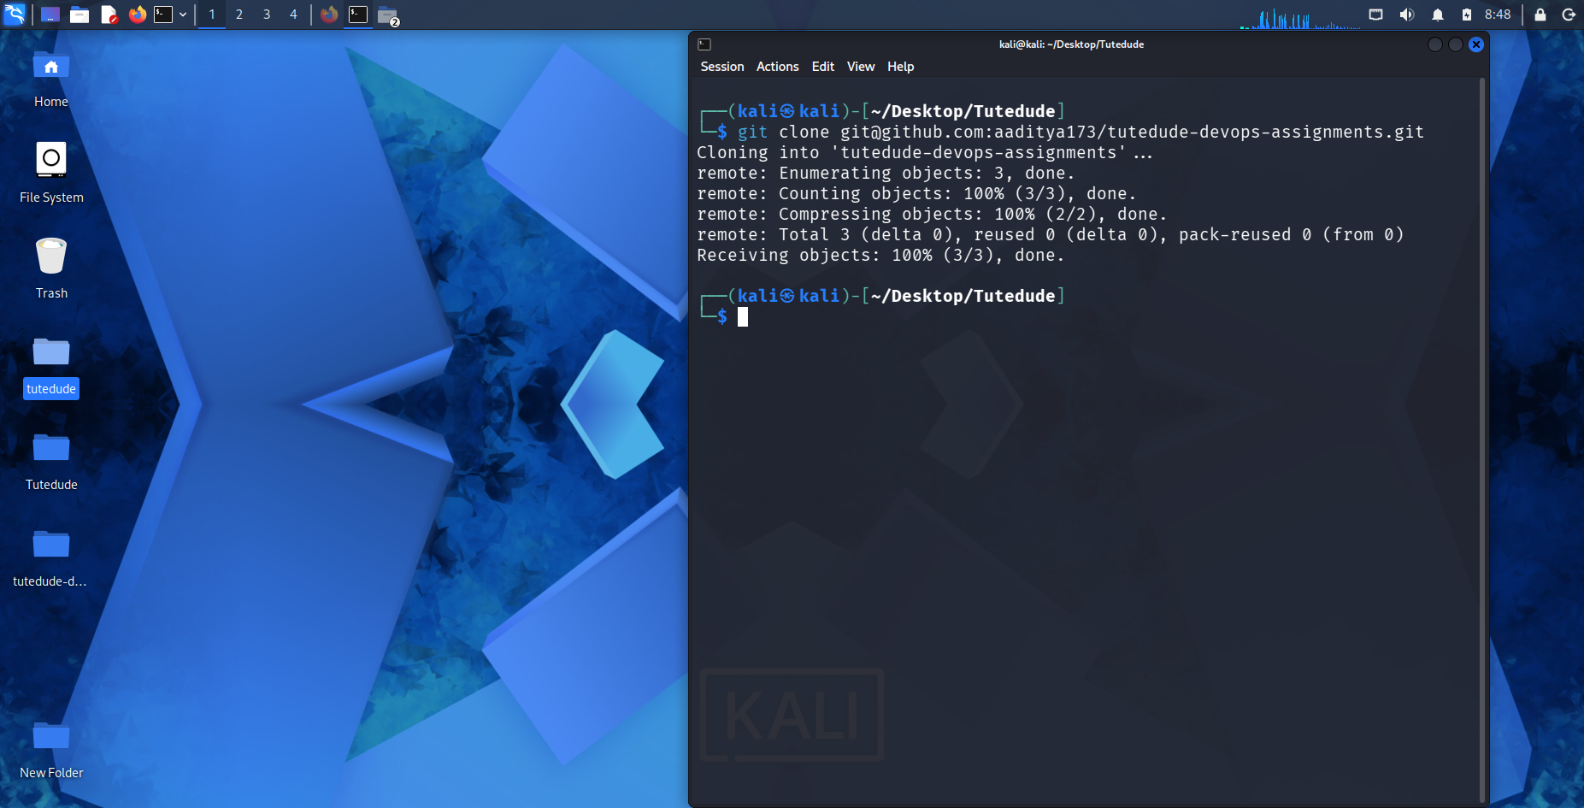

- Create a new branch named after your username (e.g., Tutedude).

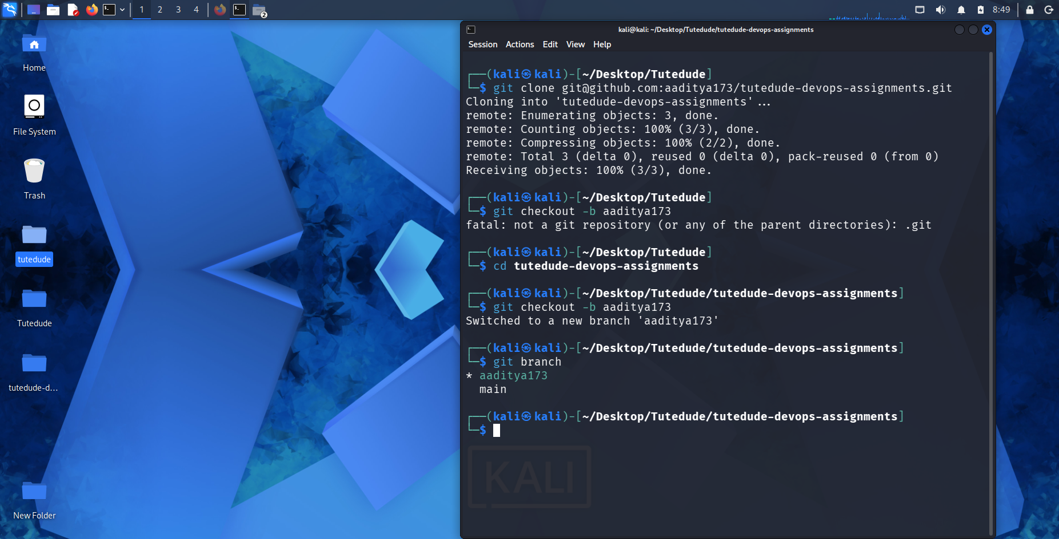
- Add your Flask project files to this branch.

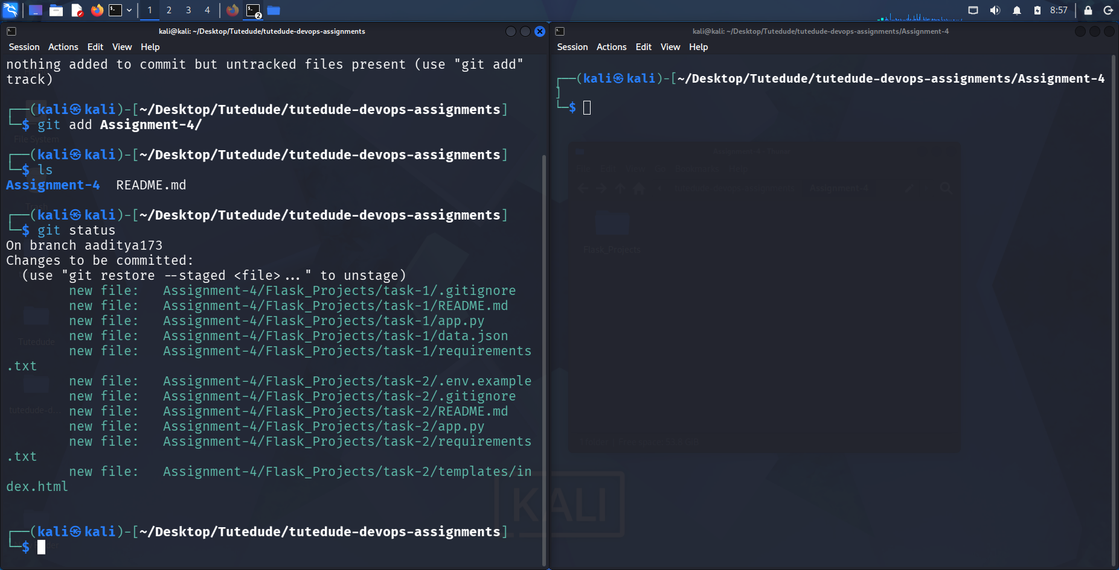

- Commit the changes and merge the branch into the main branch.
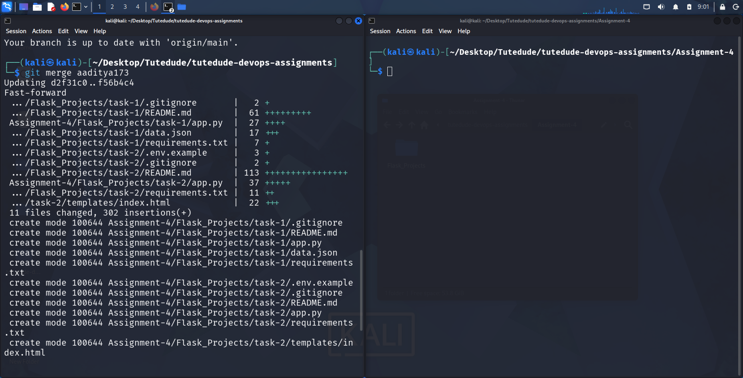

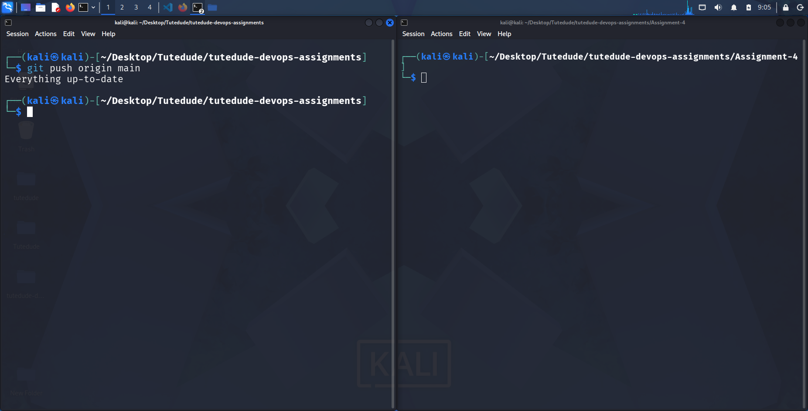
2. Create a new branch named <your_name>_new (e.g., Tutedude_new).

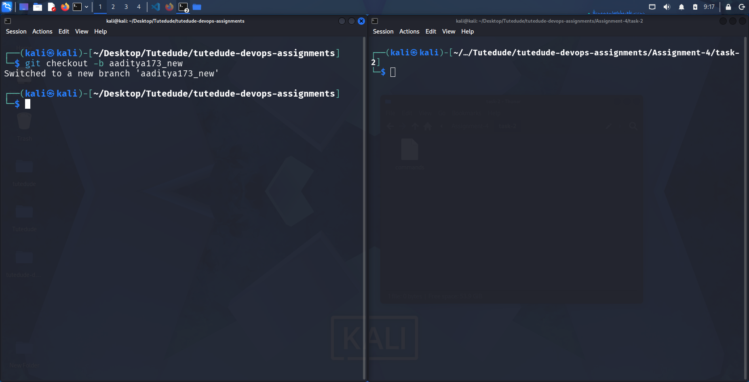
- Update the content of the JSON file used for the /api route in this branch.

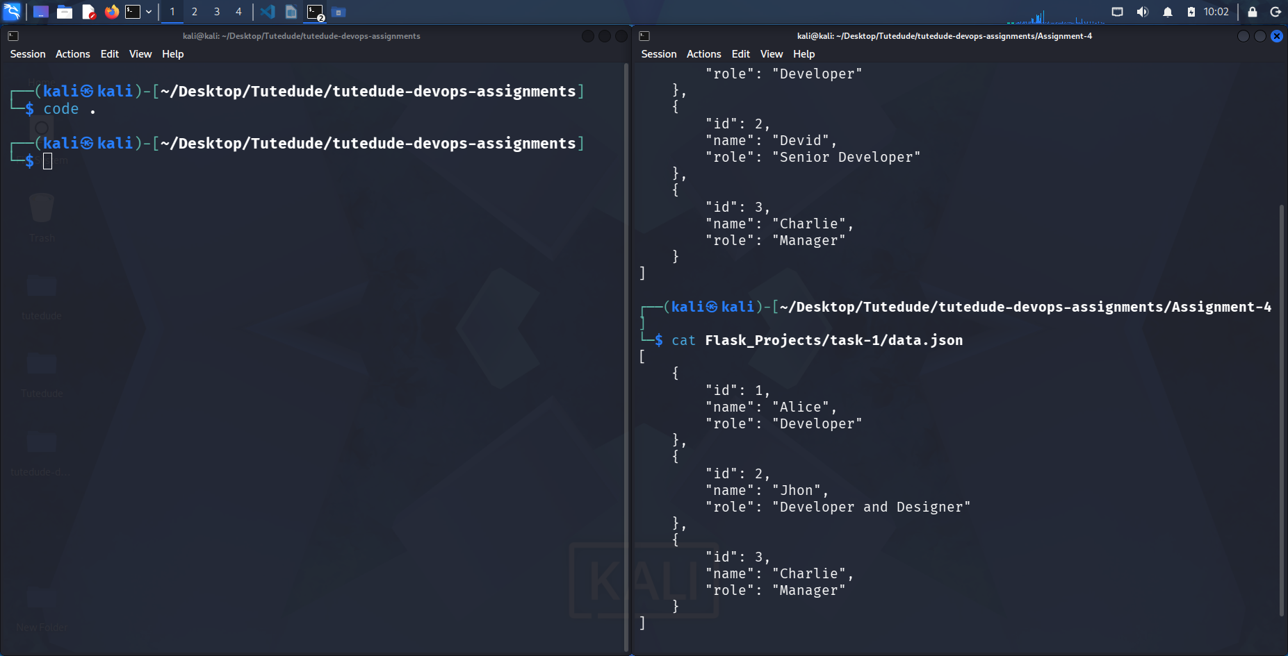

- Merge the <your_name>_new branch into the main branch.

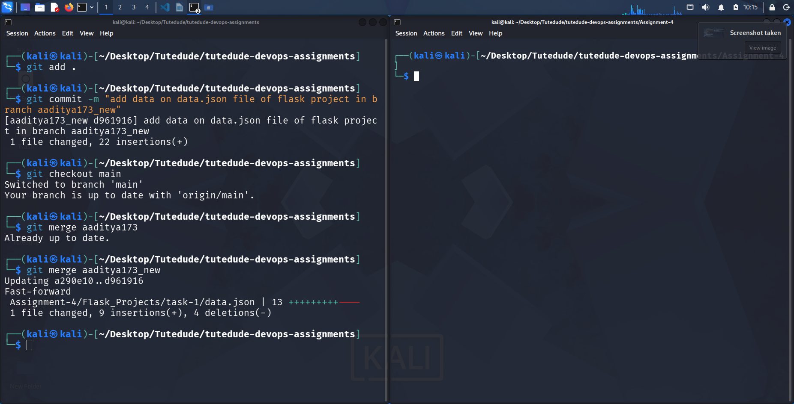

- If there are conflicts during the merge, resolve them by accepting the changes from the <your_name>_new branch.

3. Branch Creation:
- Create two branches: master_1 and master_2 from the main branch.

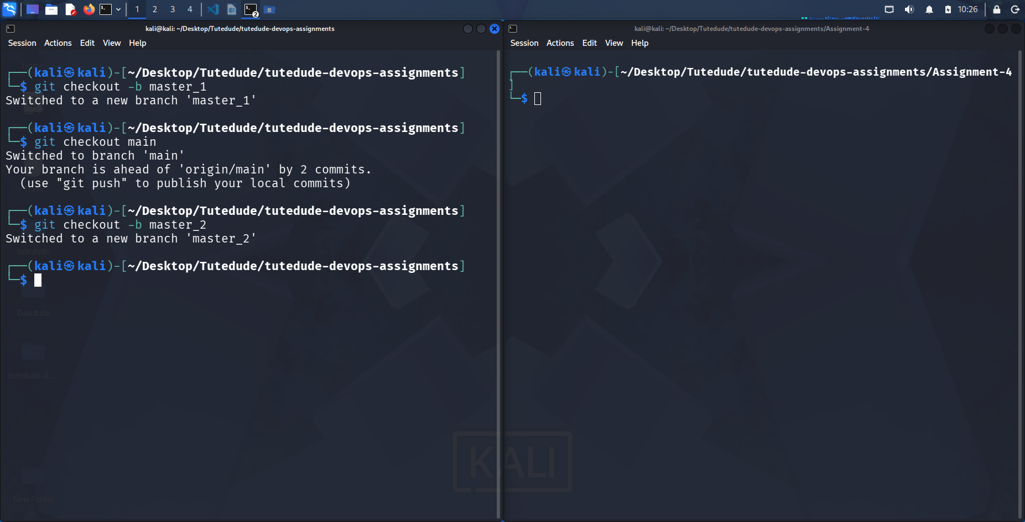
- Feature Development in master_1:
- In the master_1 branch, create a To-Do Page in the frontend.
  - The page should contain a form with the following fields:
    - Item Name
    - Item Description

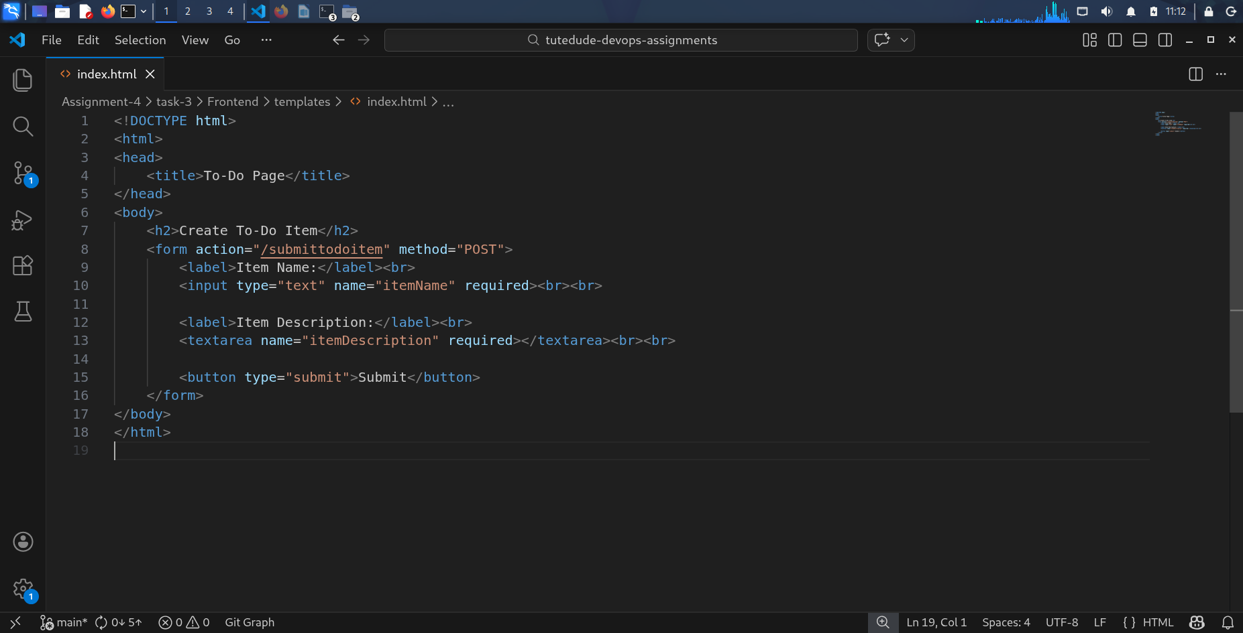
- Backend API in master_2:
- In the master_2 branch, create a backend route named /submittodoitem.
- This route will:
  - Accept itemName and itemDescription via a POST request.
  - Store these details in a MongoDB database.

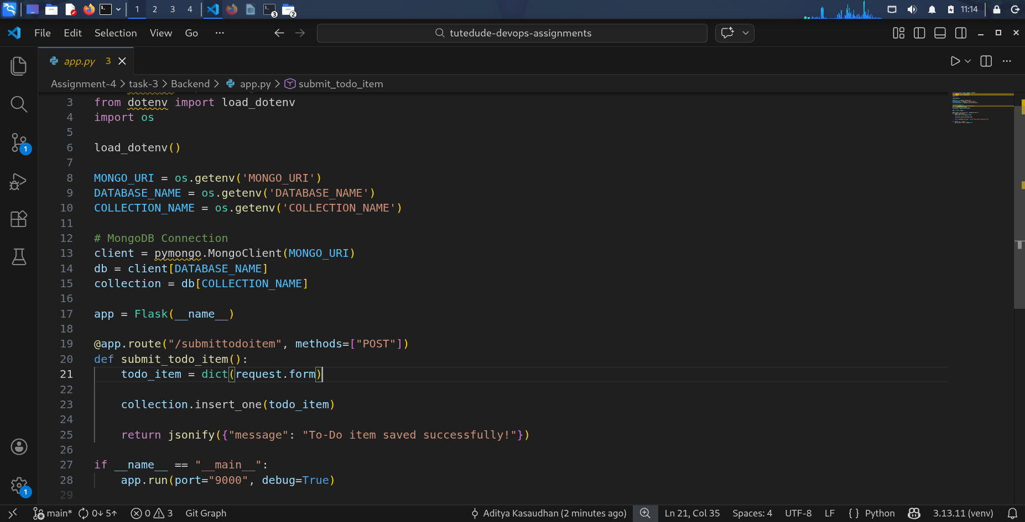

- Merging Changes:
- Merge the changes from both master_1 and master_2 into the main branch.
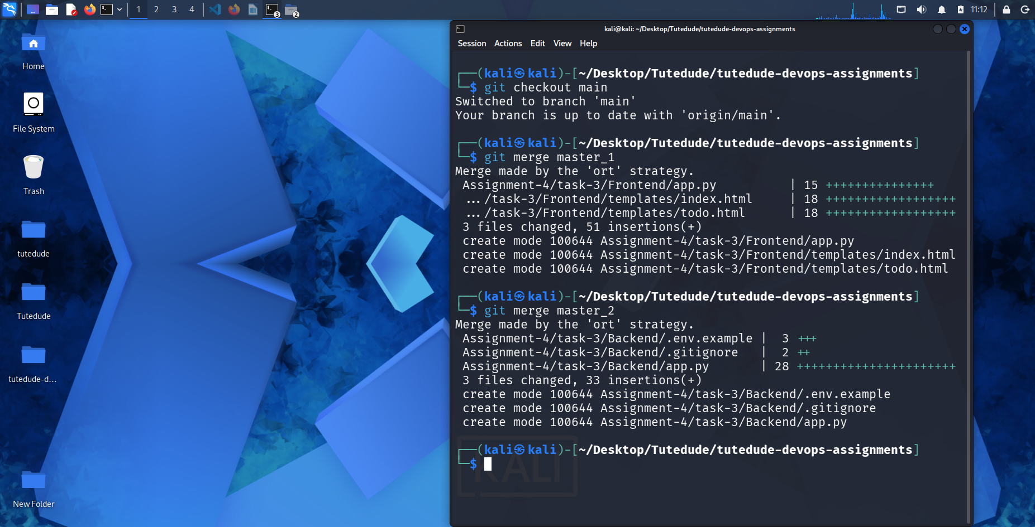
4. Enhancing the To-Do Form in master_1:
- In the master_1 branch, add the following fields to the To-Do form:
  - Item ID
  - Item UUID
  - Item Hash
- Committing in Sequence:
- Add and commit each field separately in the following order:
  - First commit: Add Item ID field.
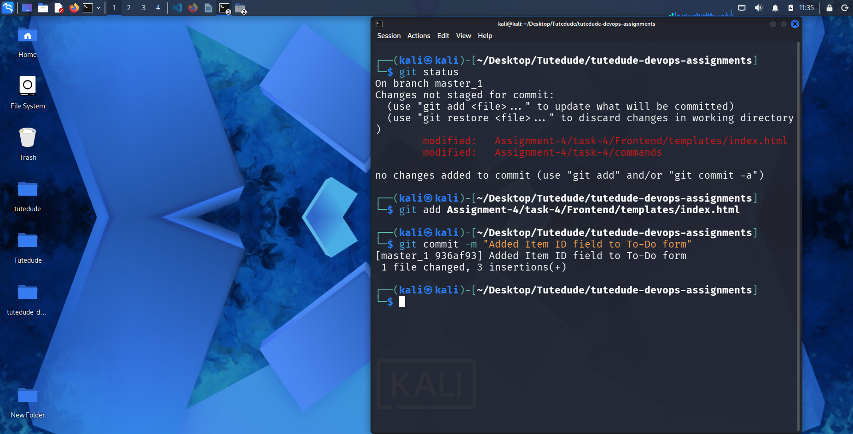
  - Second commit: Add Item UUID field.
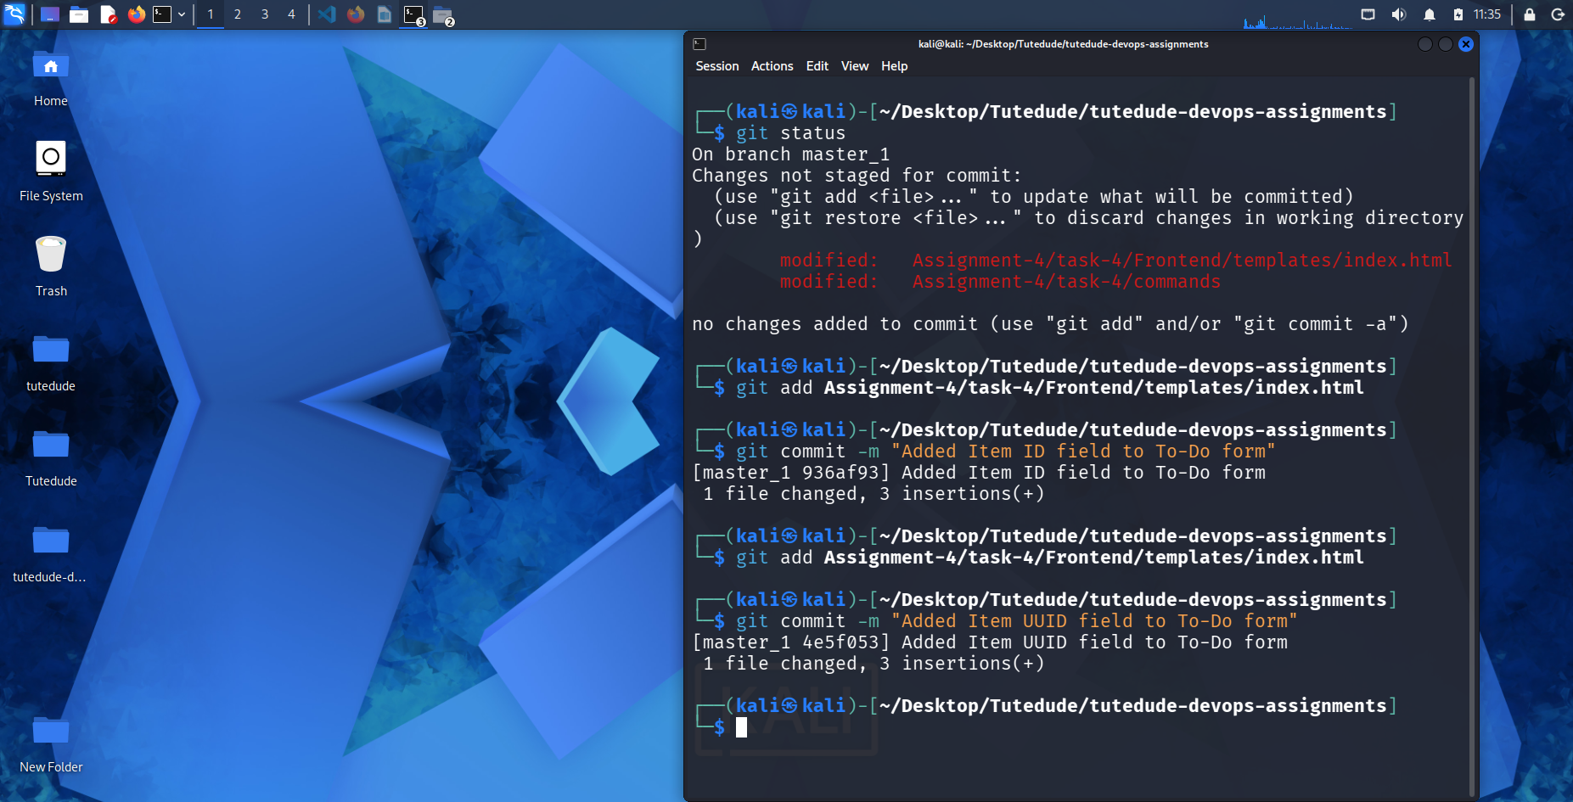

  - Third commit: Add Item Hash field.
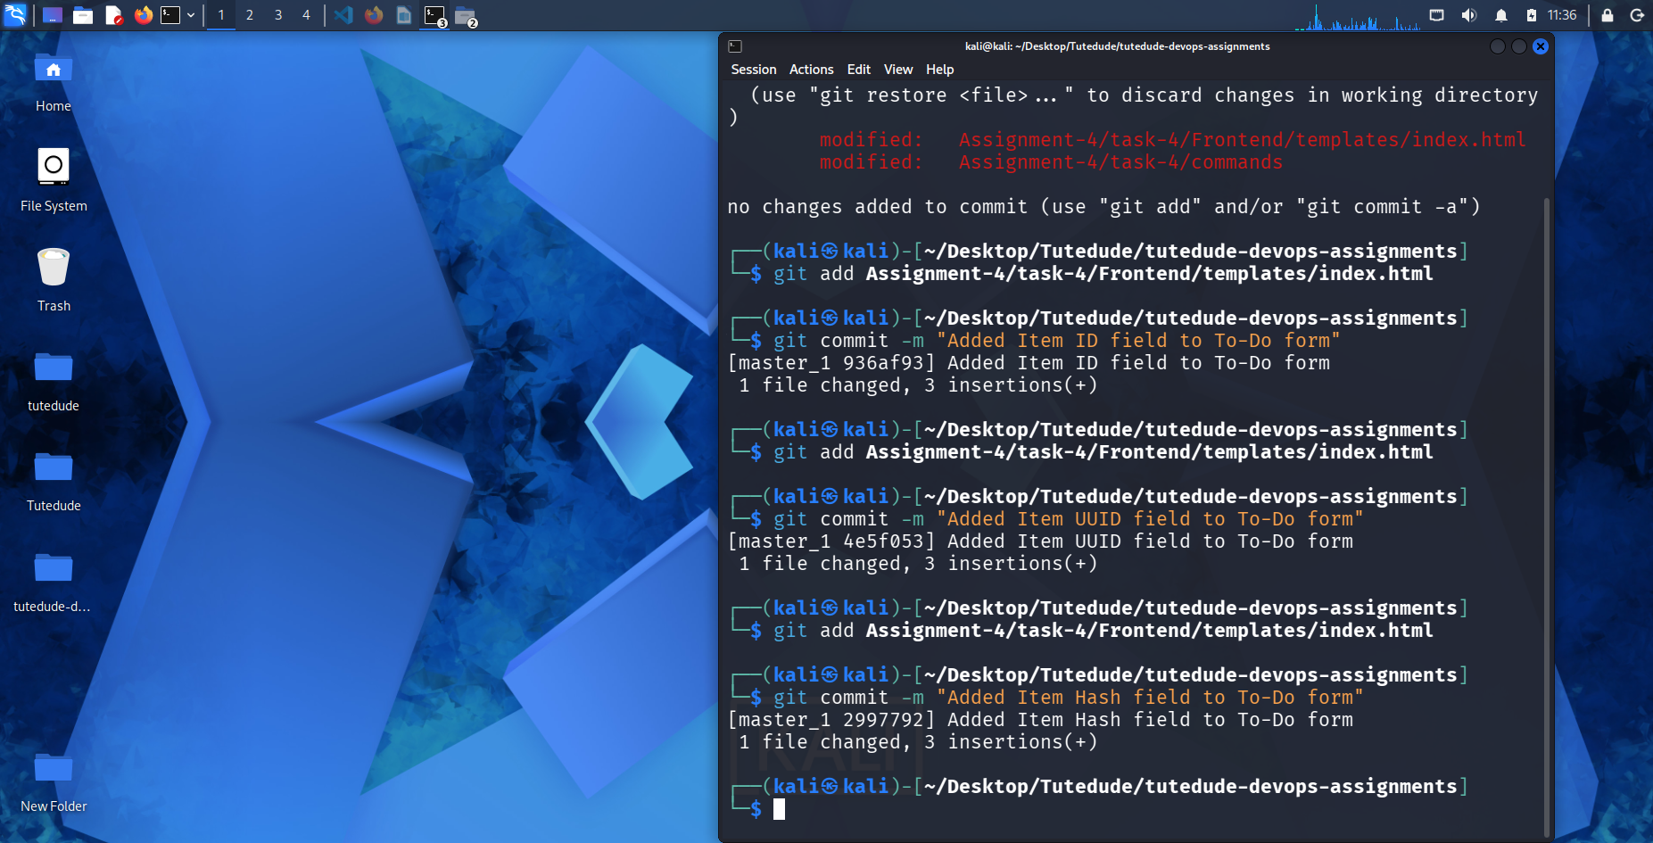

- Merging to main:
- Merge the master_1 branch into the main branch.

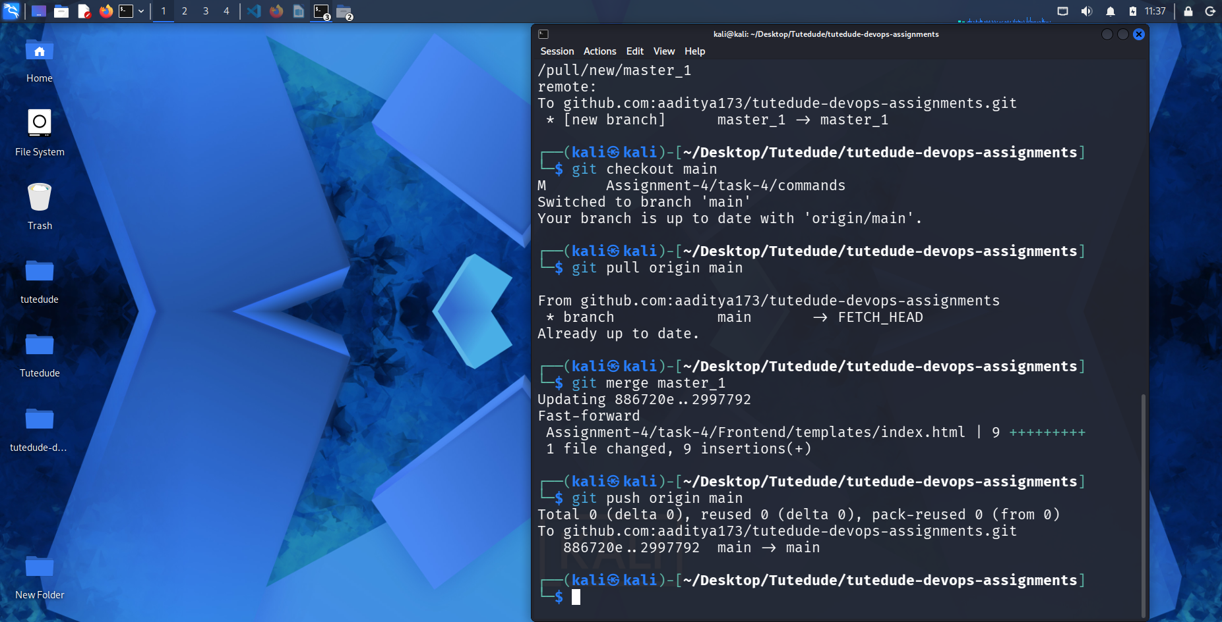

- Git Reset and Commit Deletion:
- In the main branch, use Git Reset to roll back to the commit where only the Item ID field was added.
- Use git reset --soft to ensure changes remain staged.

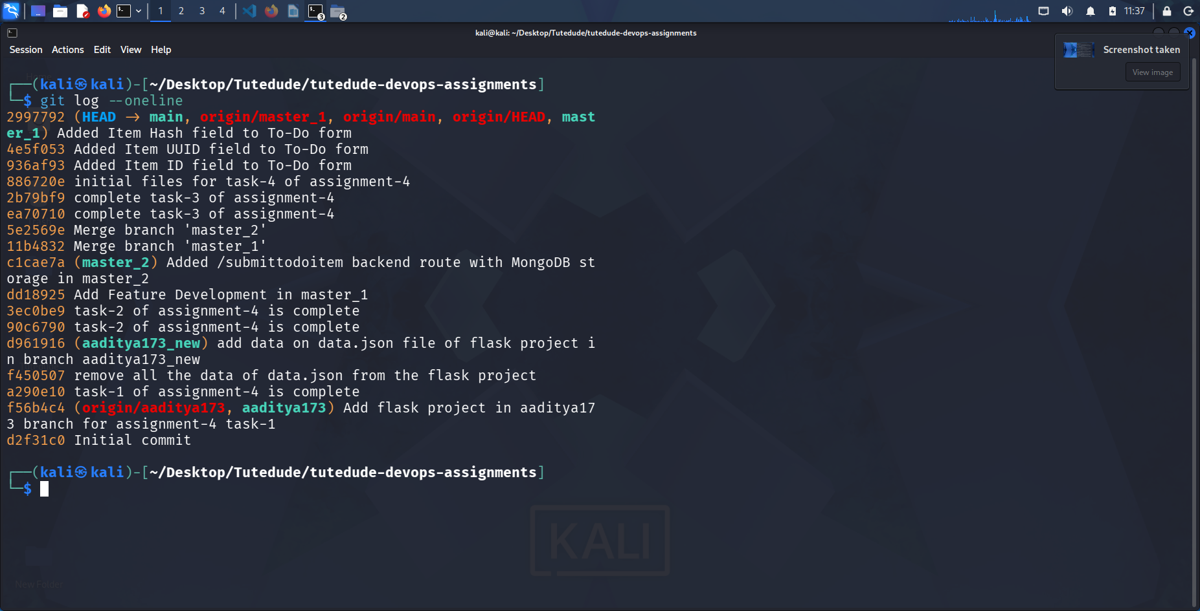
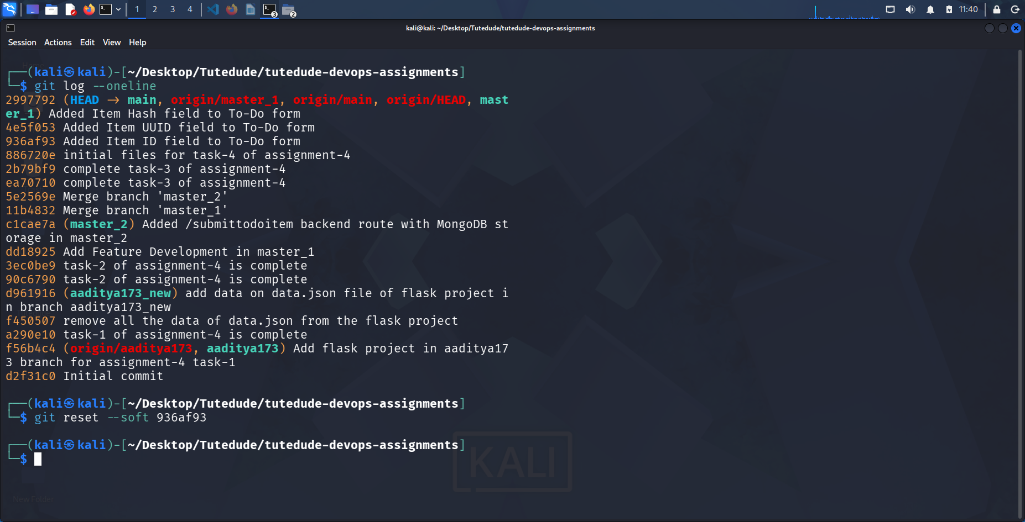

- Re-commit this state to the main branch.

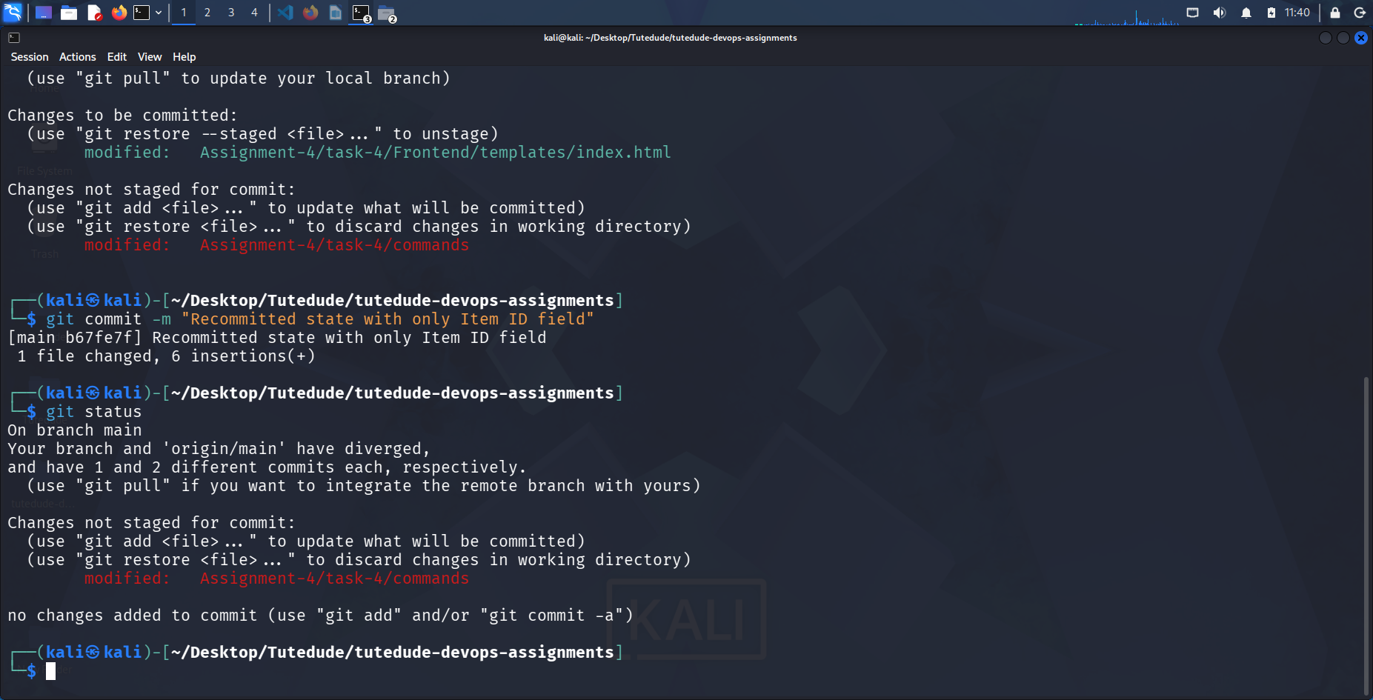
- Merge this updated state to the main branch.
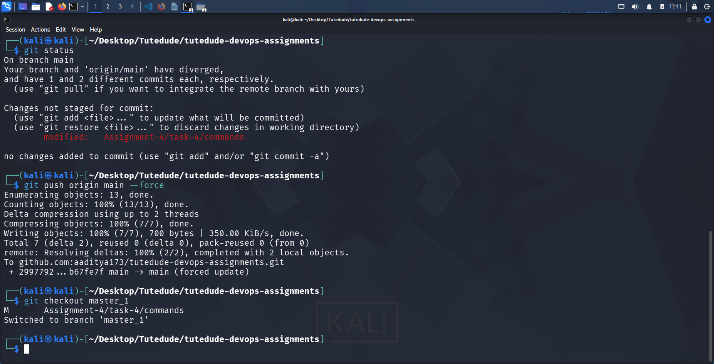

- Rebasing Changes:
- Rebase the updated changes in the main branch to the master_1 branch.
Clarification:
  - During rebasing, preserve individual commits to maintain the commit history for each change (i.e., do not squash commits).
  - Use git rebase main master_1 to integrate changes from the main branch back into the master_1 branch.


